PROMISE & PRACTICE · DEEP DIVE · SOURCE ANALYSIS
The Compromise of 1877 — A House Divided
Necessary Peace, or Betrayal?
Name: ______________________________ Period: _____ Date: ________________
WHAT I CAN DO TODAY I can read primary sources about The Compromise of 1877 — A House Divided, weigh who made each one and why, and use evidence to answer historical questions.
Directions. A real argument can be made on both sides. Weigh them, then take a defensible position

THE SOURCES
THE IMAGE · C.1877 — President Rutherford B. Hayes
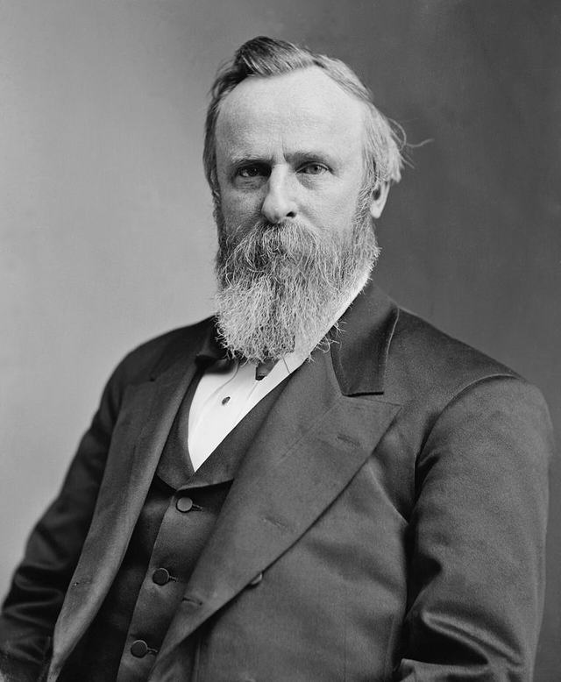
President Rutherford B. Hayes — photograph, Brady–Handy studio, c.1877, public domain (Library of Congress).
SOURCE · THE TERMS OF THE DEAL — What each side got
Republicans got: the presidency — Rutherford B. Hayes.
Democrats got: the withdrawal of the last federal troops from the South, ending federal protection of Reconstruction governments and Black citizens.
— summary of the Compromise of 1877. Public domain
— summary of the Compromise of 1877. Public domain.

YOUR WORK
QUESTION 1 STEP 1 · THE CRISIS
Why was the 1876 election so dangerous and hard to resolve? What might have happened without a compromise?
____________________________________________________________________________________________
____________________________________________________________________________________________
____________________________________________________________________________________________
QUESTION 2 STEP 2 · THE COST
What did the withdrawal of federal troops mean for Black Southerners?
☐ A. it removed their last protection, leaving them to the ‘Redeemer’ governments
☐ B. it gave them land
☐ C. it guaranteed their voting rights forever
☐ D. it had no effect on them
QUESTION 3 STEP 3 · BOTH SIDES
Make the best case for each view: (a) the Compromise was a necessary peace that avoided a dangerous crisis; (b) it was a shameful betrayal of the freedpeople.
____________________________________________________________________________________________
____________________________________________________________________________________________
____________________________________________________________________________________________
____________________________________________________________________________________________
QUESTION 4 STEP 4 · YOUR POSITION
Using Douglass's warning and the evidence, take a position: was the Compromise of 1877 a necessary peace or a betrayal? Defend it in three or four sentences.
____________________________________________________________________________________________
____________________________________________________________________________________________
____________________________________________________________________________________________
____________________________________________________________________________________________
____________________________________________________________________________________________
Promise & Practice · ShadowDog Digital Studios · Unit 2

TEACHER ANSWER KEY — The Compromise of 1877 — A House Divided

QUESTION 1: Open response.
Look for a response along the lines of: “The election was dangerous because…; without a deal…”
QUESTION 2: Correct — A. it removed their last protection, leaving them to the ‘Redeemer’ governments
Right. The troops were the last protection for Black citizens and Republican governments. Their withdrawal left freedpeople at the mercy of the ‘Redeemer’ governments — effectively ending Reconstruction.
QUESTION 3: Open response.
Look for a response along the lines of: “Case (a): it was necessary because…. Case (b): it was a betrayal because…”
QUESTION 4: Open response.
Look for a response along the lines of: “I argue that the Compromise of 1877 was ___ because…”

